2nd Assignment :
Description : create three respository having index.html file in it then create a Jenkins job for each of it and output should be when we will run first job it will show first website with IP and if we run second job it will show second website using ip and first should be delete…
1)Create three repository with index.html file in it
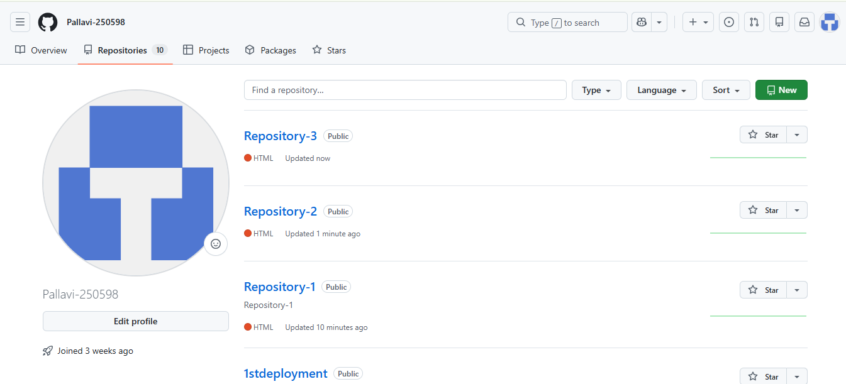
2)1st Repo 1st index.html
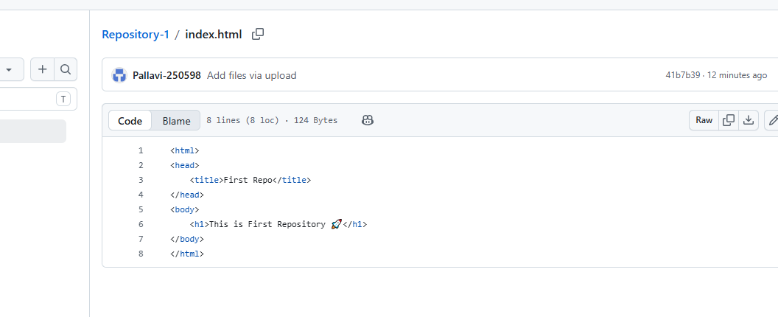
3)2nd Repo 2nd index.html
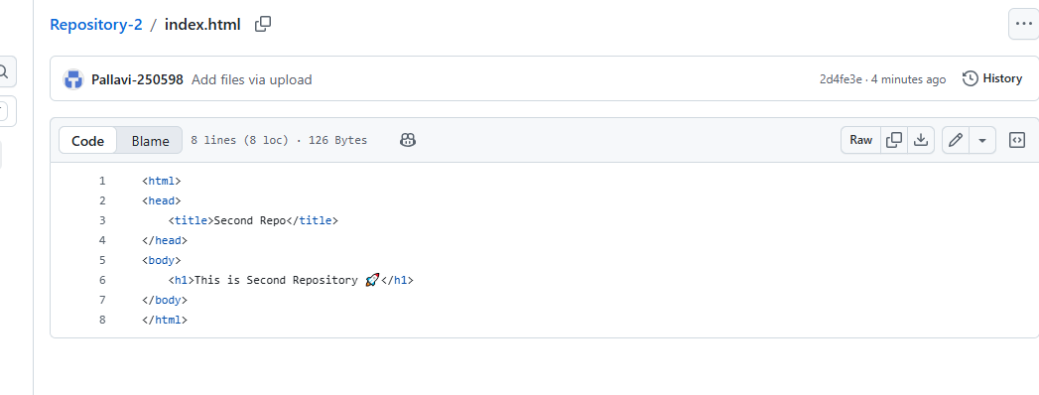
4)3rd Repo 3rd index.html file
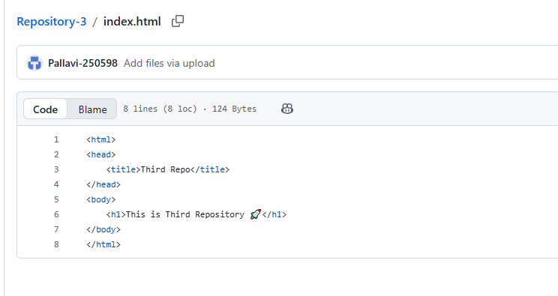
5)open master GIT
create 1st job with 1st repo :
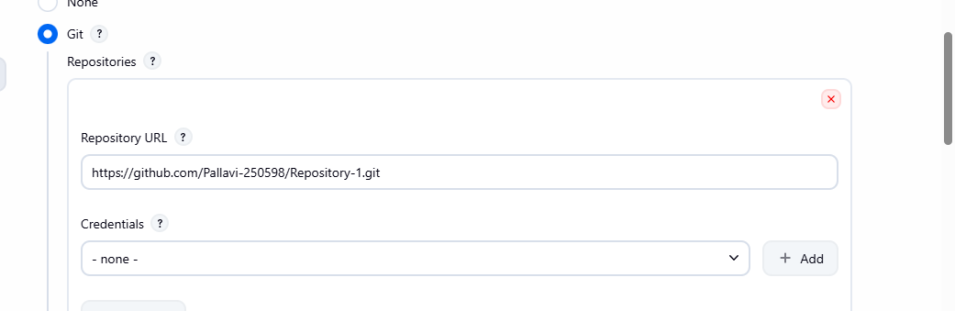
6)and add this script in execute shell so that old index.html file will be deleted
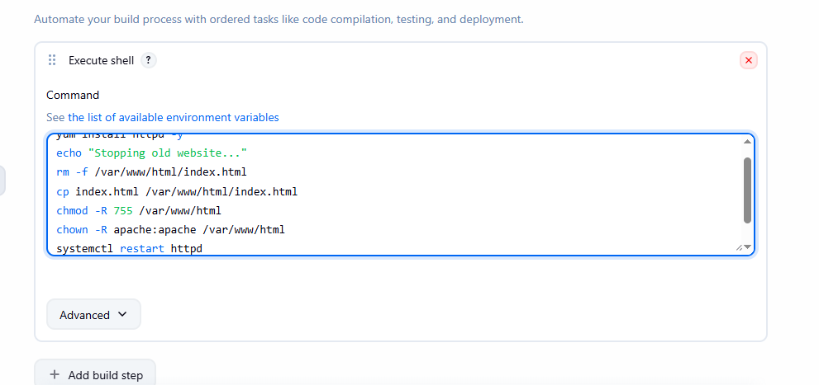

7)create 2nd job with 2nd repo :
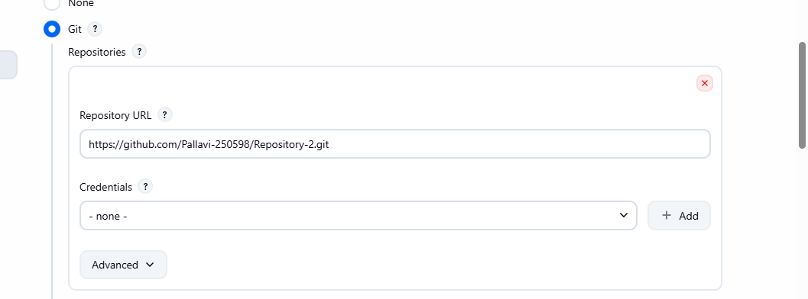
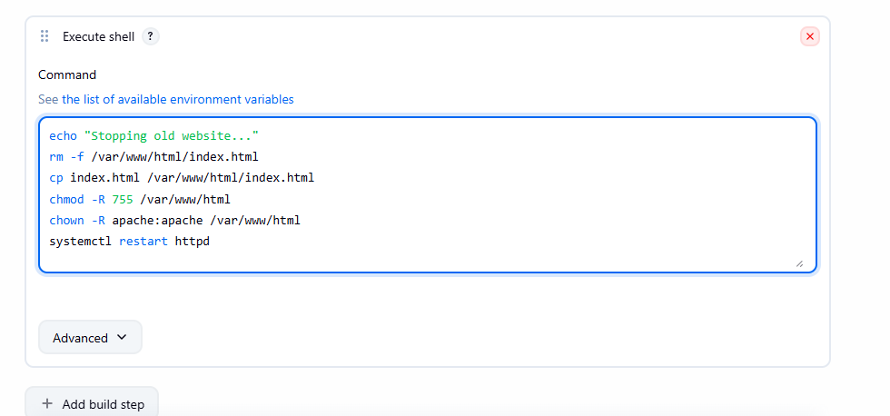

8)create 3rd job with 3rd repo :
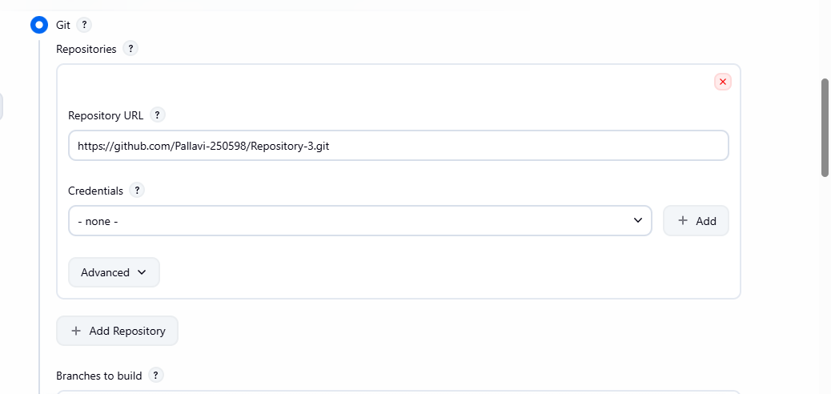
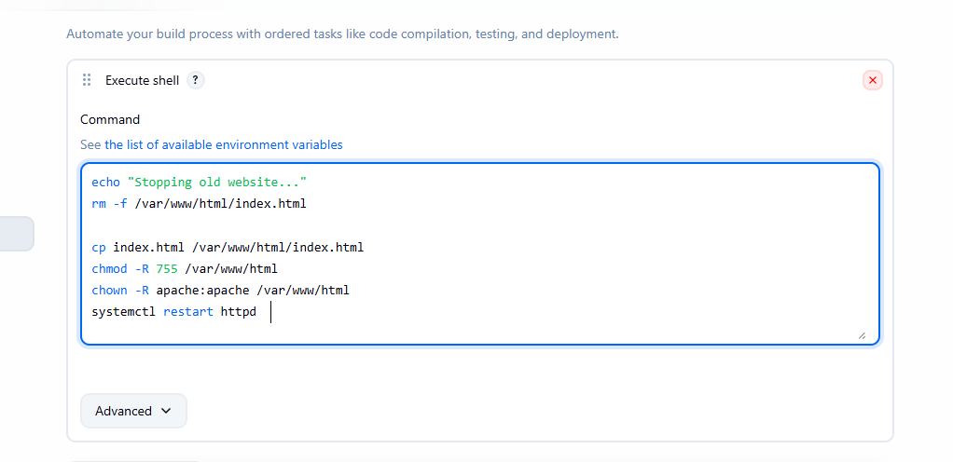
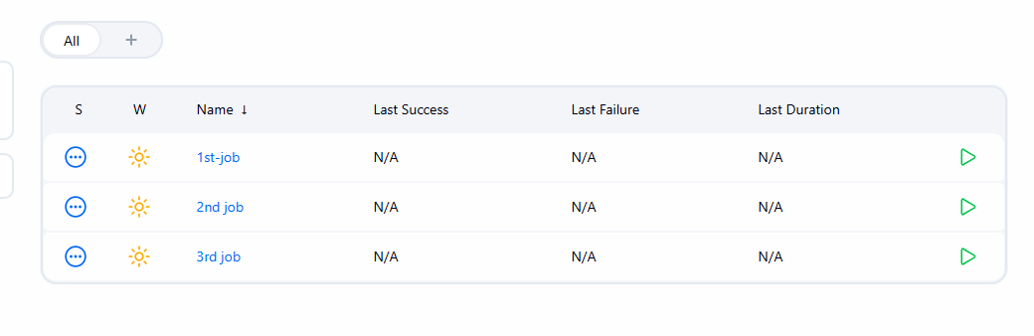
9)Now try to host website running 1st job :
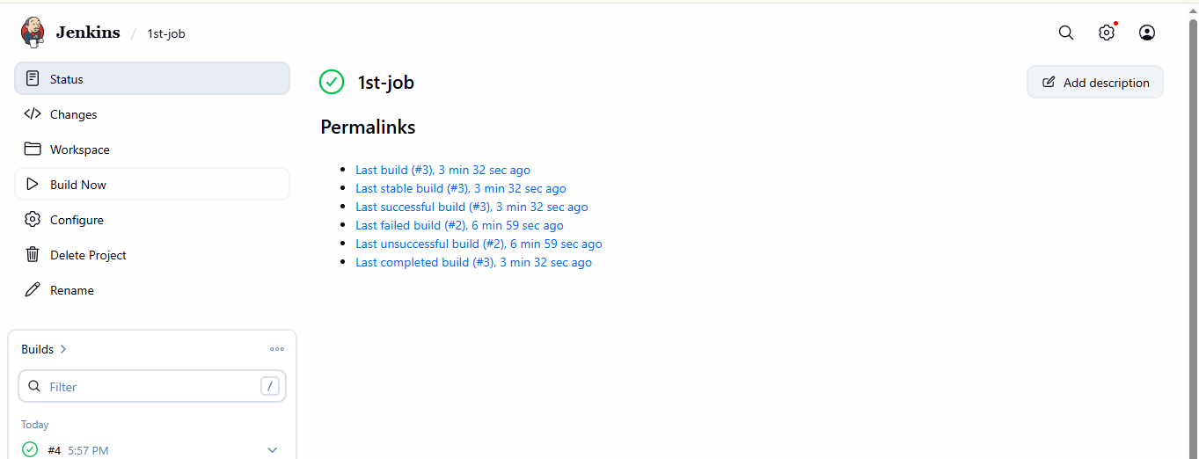
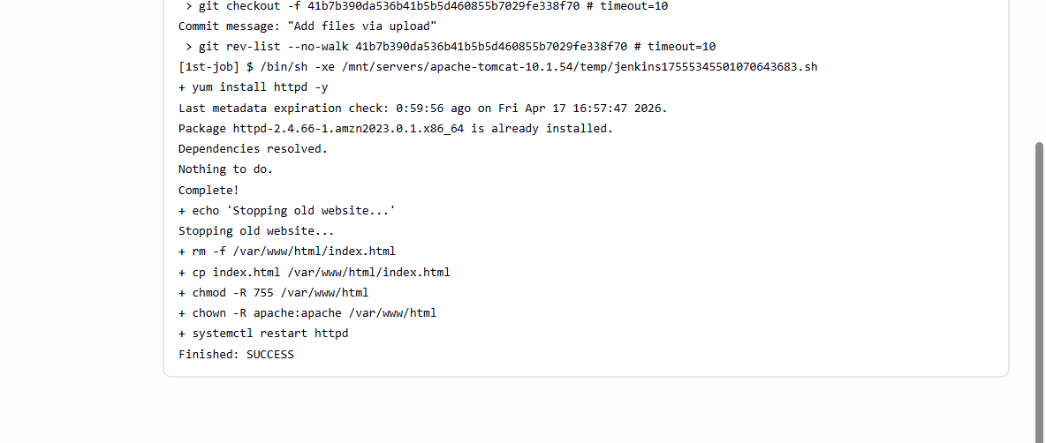

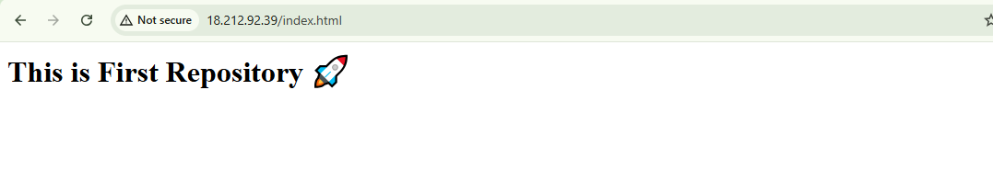
10)now try to run second job
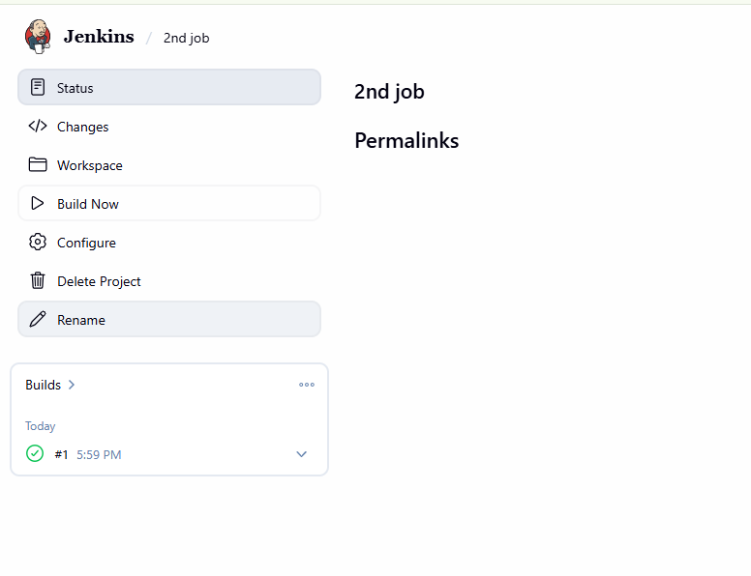
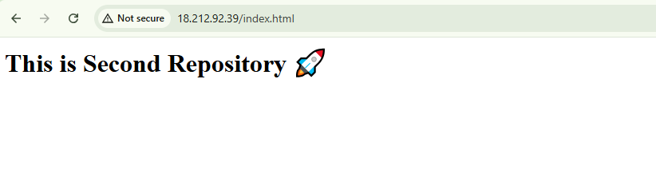

3rd job :
